**Task1.Subtask1**

Using the **Accelerometer** **sensor** in the given device and the **connectionService** service in android, the data from the sensor is collected. This application also demonstrates how a raw data from the sensor could be converted to the useful data.

In the below given phone screenshot images, the collected from the sensor can be noticed. When the device is moved the values are changed, which can be observed in Figure.2

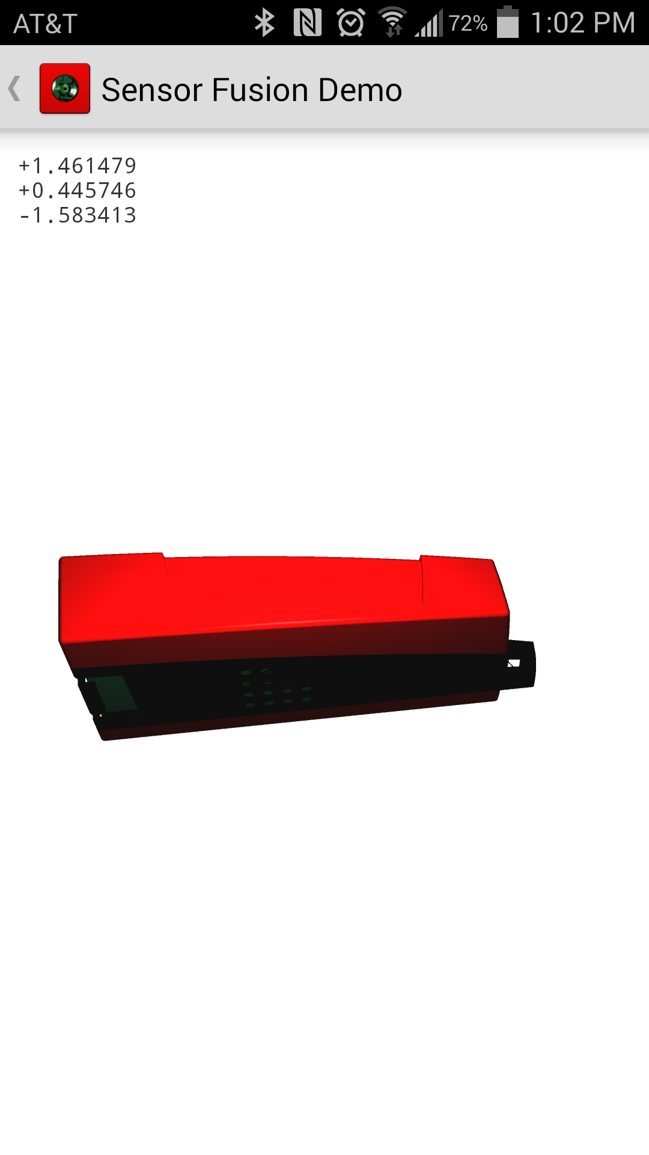

**Figure 1**

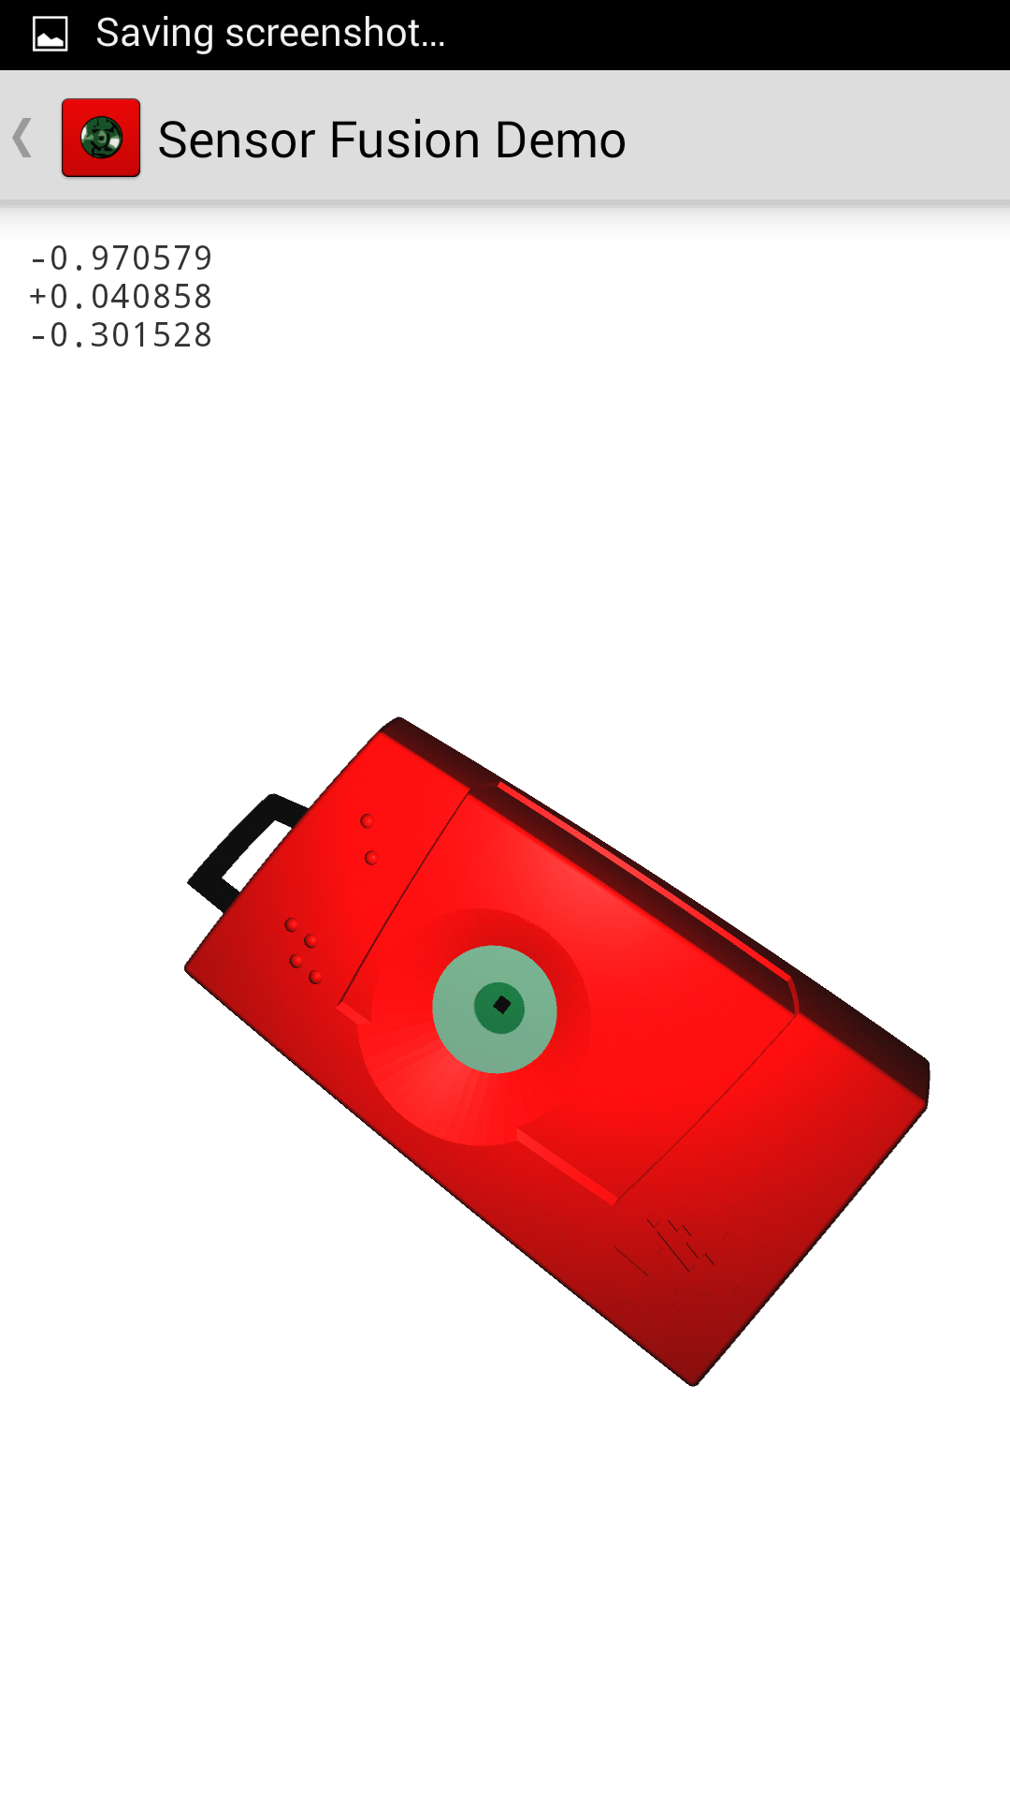

**Figure 2**

The above screen shots are captured using the "BLE Sensor tag". We couldn't capture the values in the Logcat because it is displaying error **"Callback connection failed"** for the device. Error screen given below

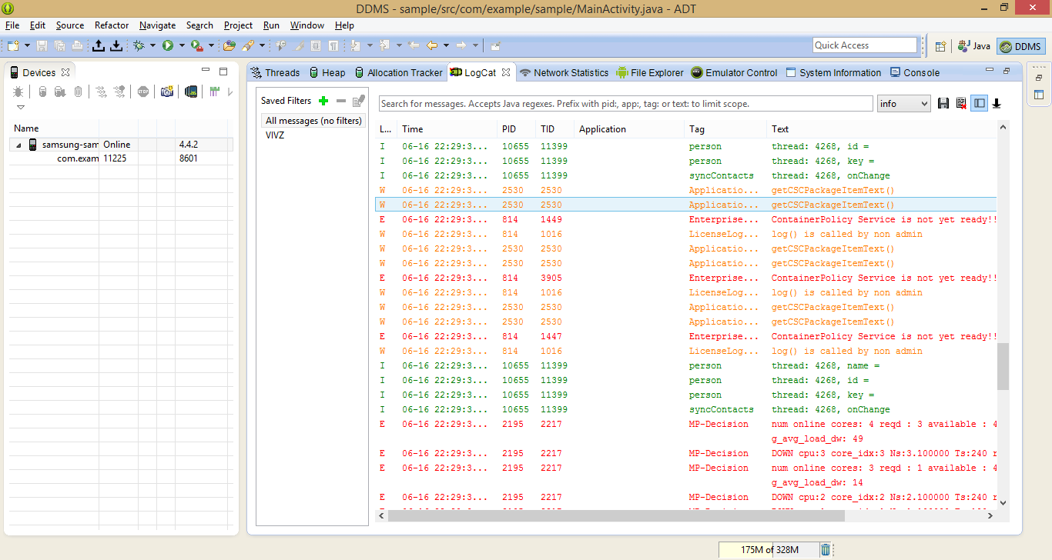

**Figure 3**

**Task1.Subtask2**

Using the built in sensor and SensorEventListener interface in android, an application of developed, which changes the color when the sensor detects that the device was shuffled. The change of colors can be identified from the screen shots in Figures 4 and 5

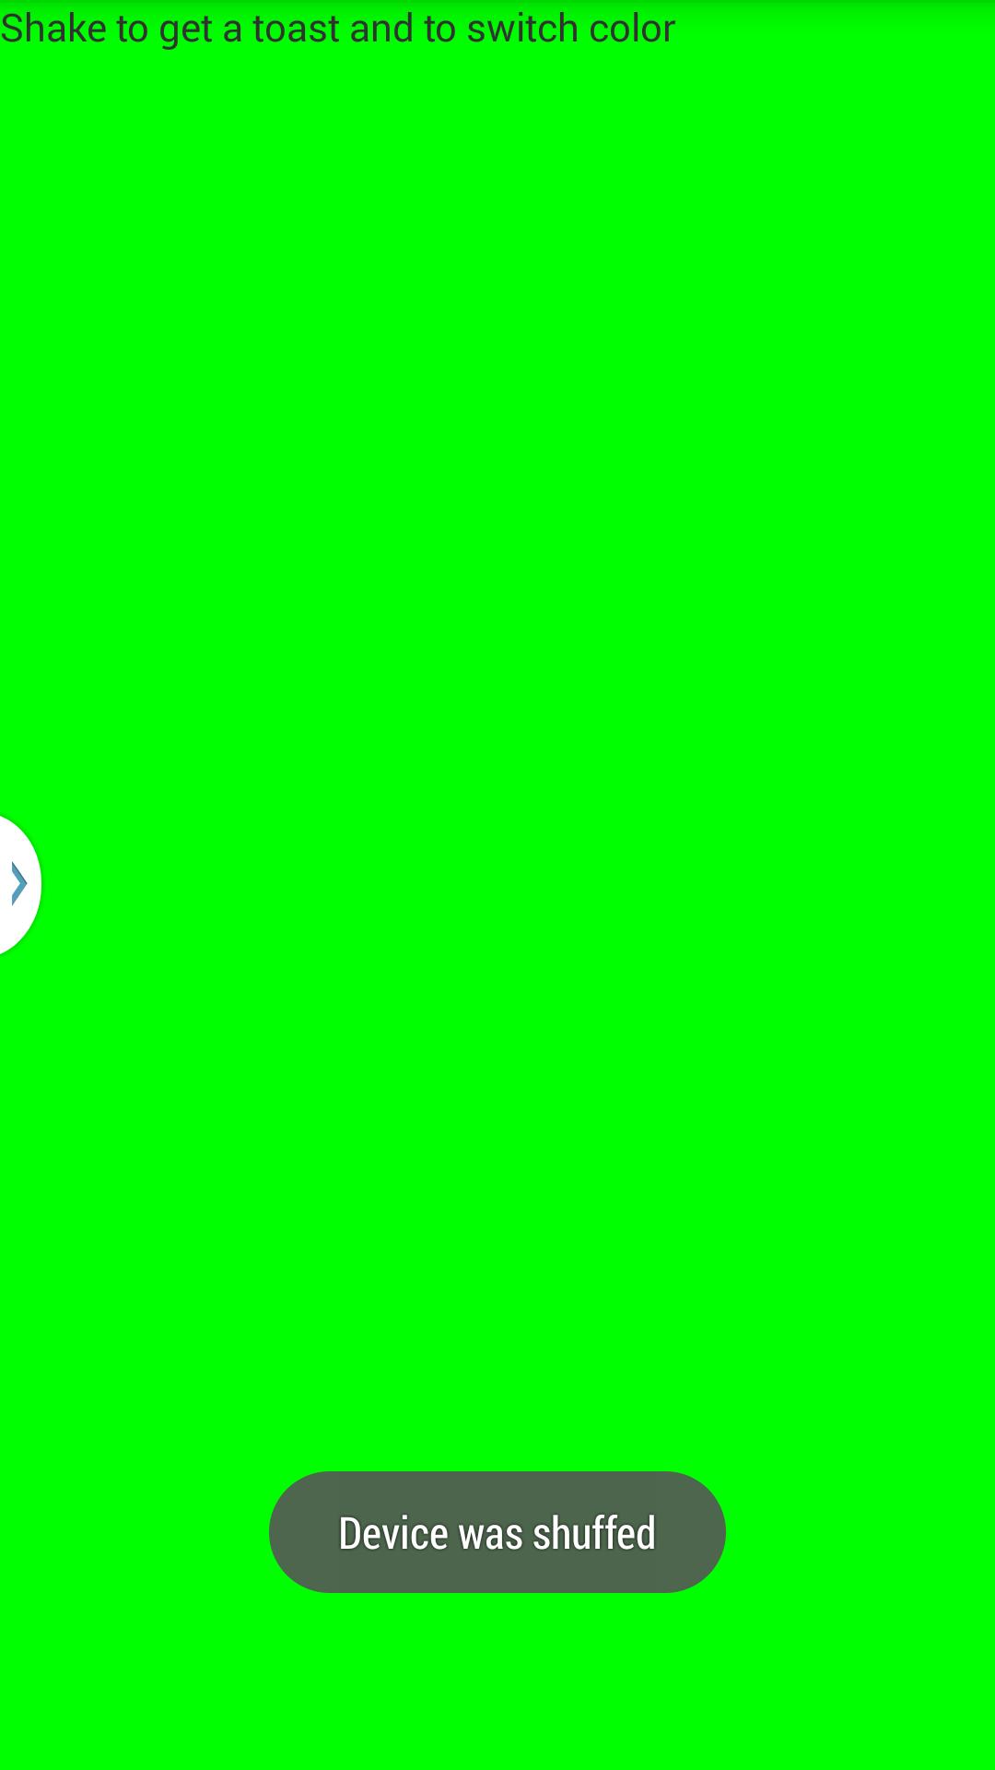

**Figure 4**

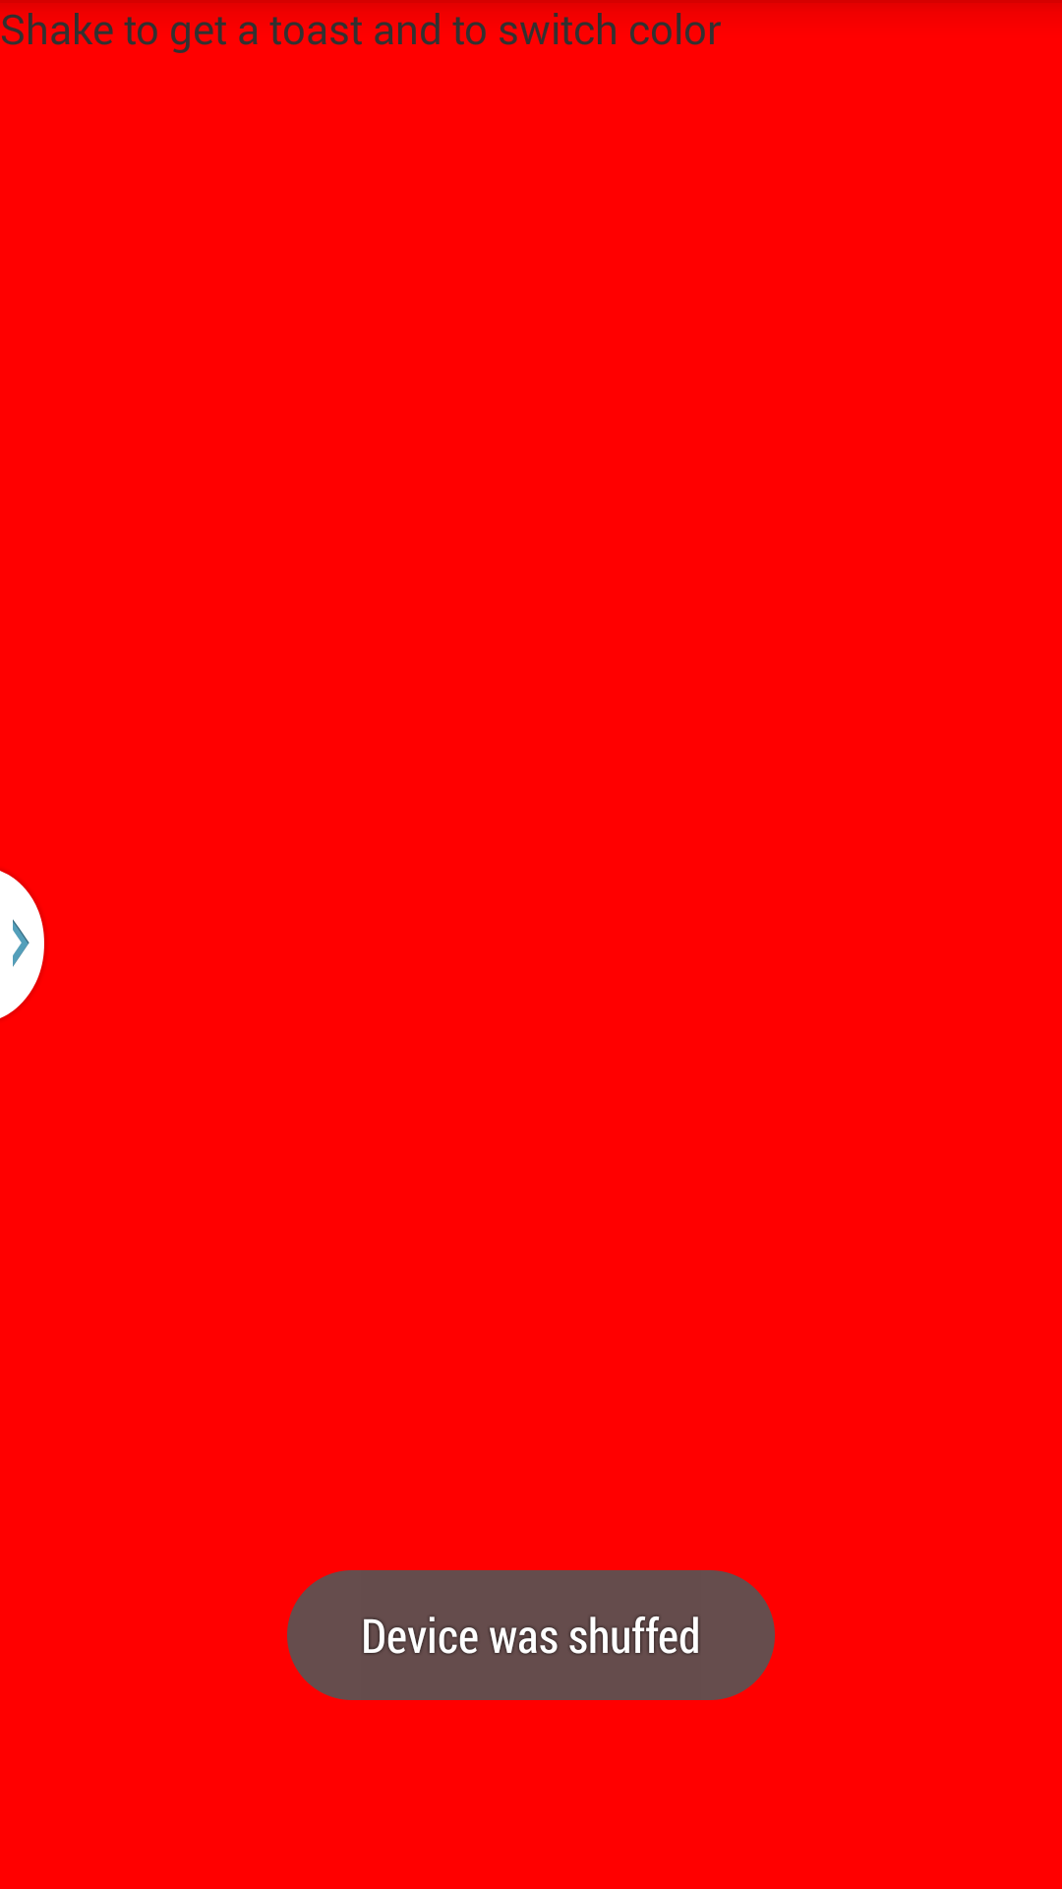

**Figure 5**

**Task1.Subtask3**

An application is developed using the Android GPS feature. When we run this app, current address, Longitude and Latitude values will be displayed. The same can be noticed in the Figures 6 and 7 below.

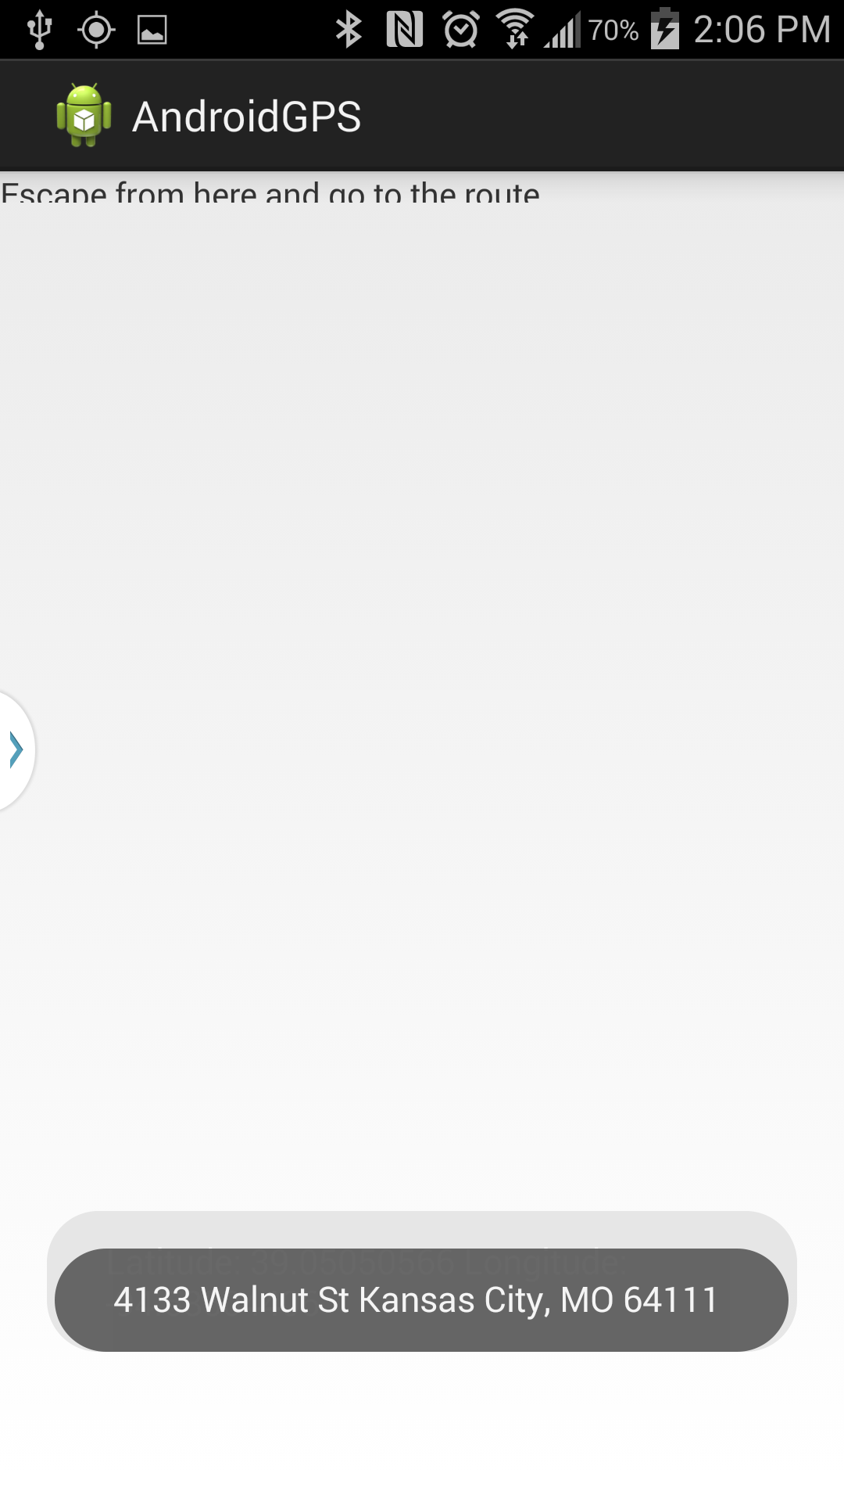

**Figure 6**

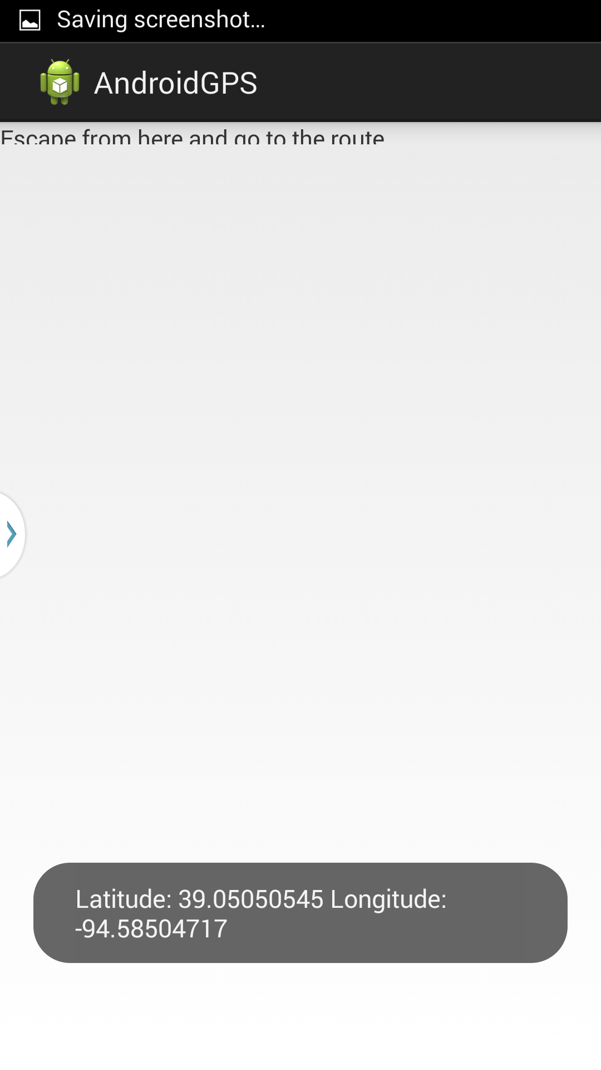

**Figure 7**

**Task1.Subtask4**

A wireless gesture based recognition app is developed and the captured gesture is compared with the previous captured gesture to find the similarity in both the gestures. Level of similarity in both the gestures will be given by the probability

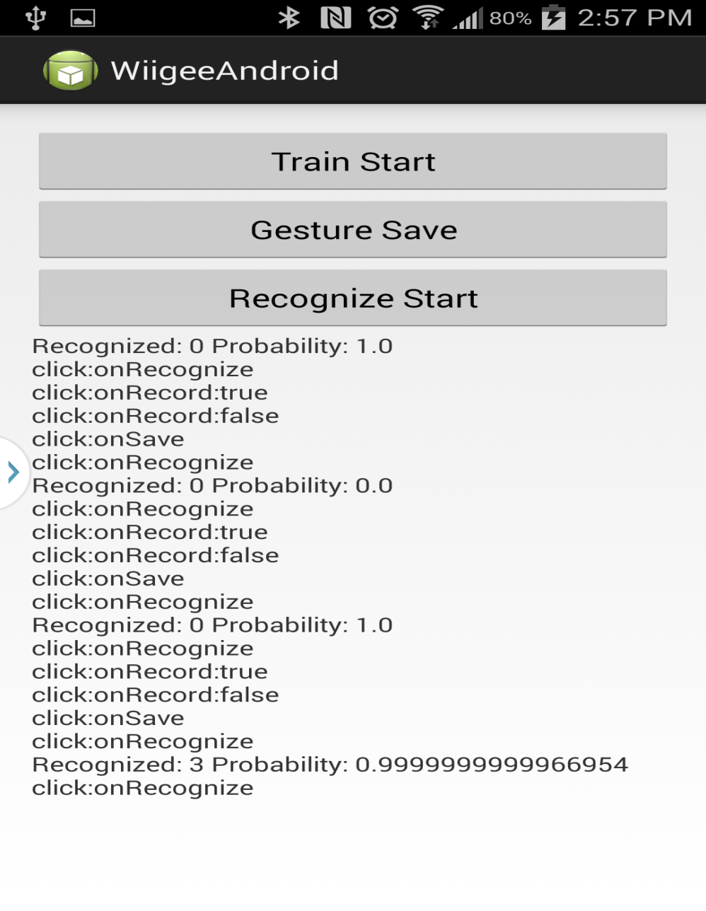

**Figure 8**

**Task1.Subtask5**

Using the chronos watch, densor tag device and the punchmeter application, the movement in the sensors are captured and the raw data from sensors is converted into understandable data. Various operation modes of chronos watch was learnt in this task.

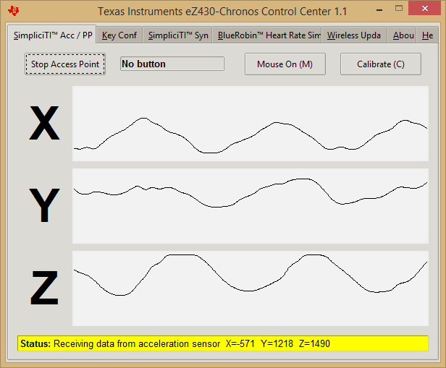

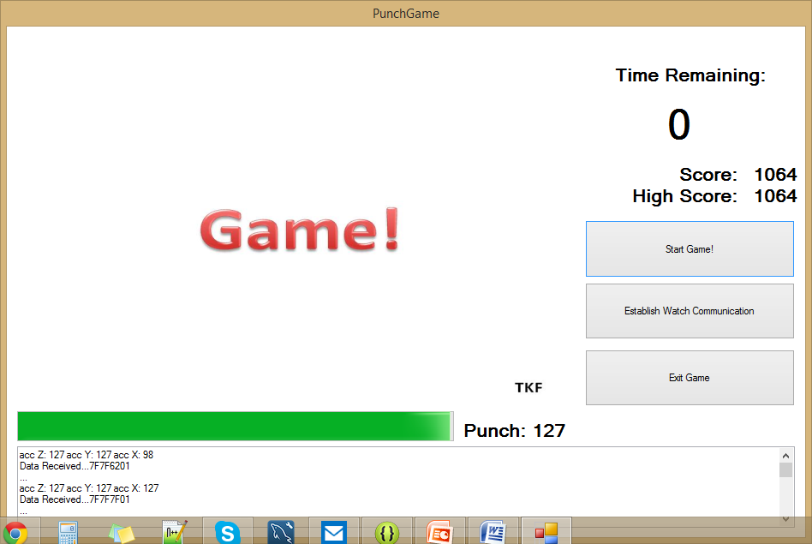

**Task2: Cloud Era**

Cloud era is the open source hadoop framework. We can access the servers remotely we can run the programs on this framework from the remote location. Advantage of the hadoop framework is it manages the distribution task of the work and again merges the output from different processors and display the output to the user. With distribution of work, processing time decreases rapidly.

**SubTask1:** Following is the screenshot for accessing the cloudera

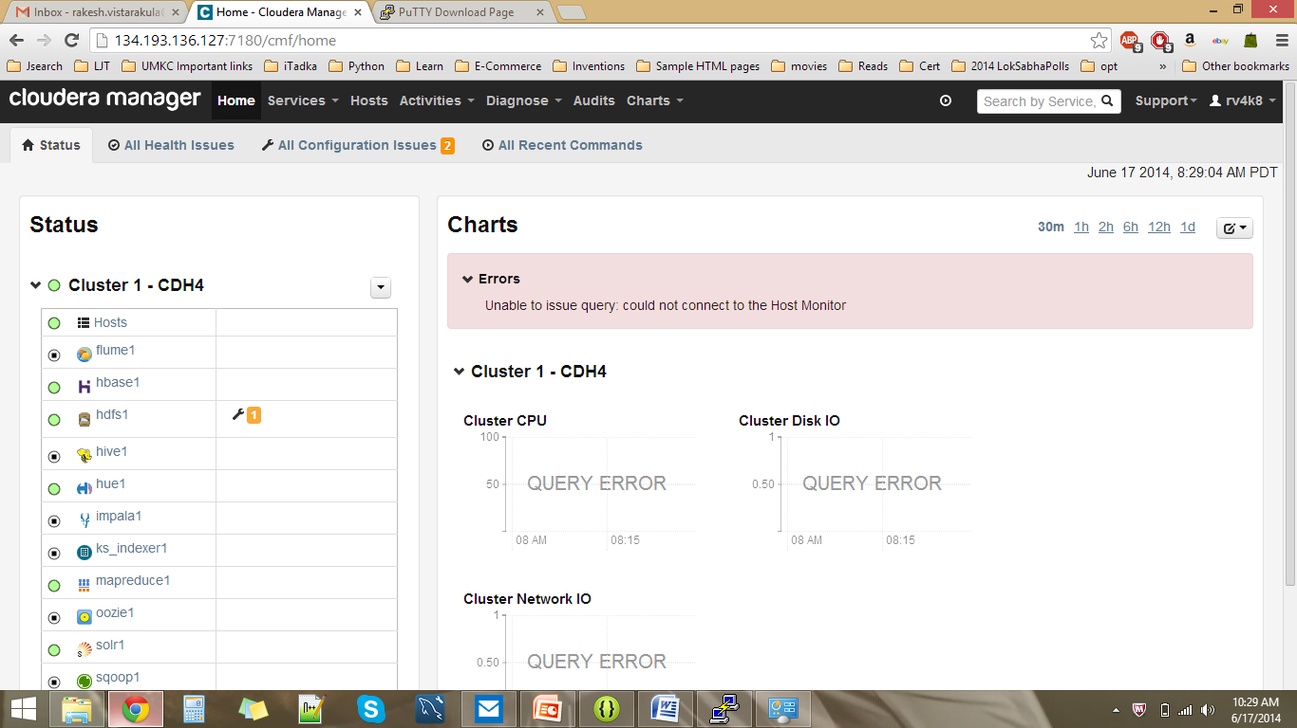

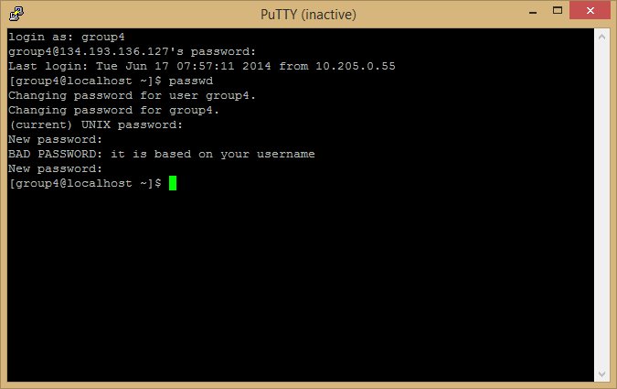

**SubTask2:**

Own cloudera server can be installed by following the following steps:

>> First, we need to install Vmware player, which can be downloaded from the following location

* <http://www.vmware.com/products/player>

When we install and open the Vmware player, it will be as follows:

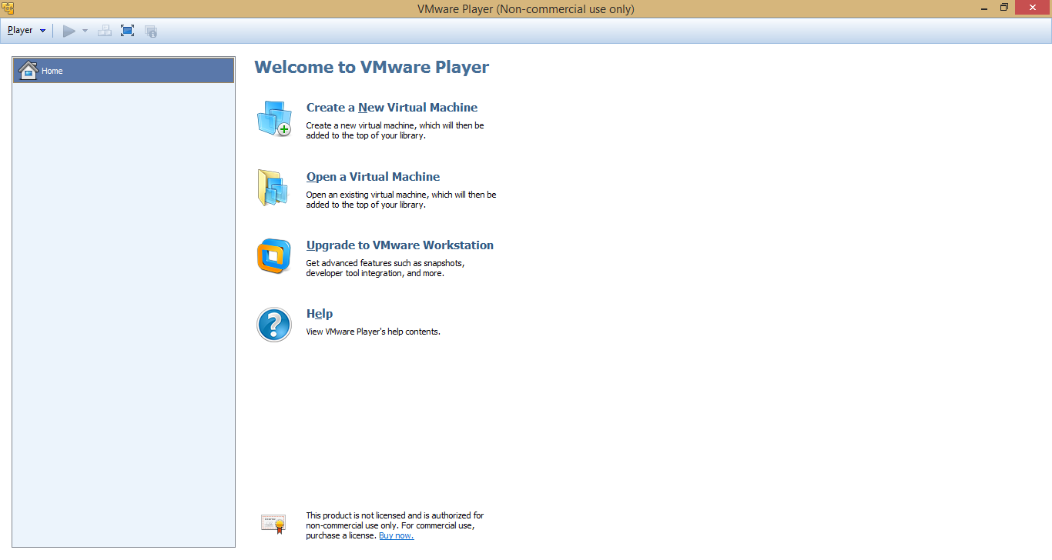

>> After installing the VMware, install the quickstartVM(Cloudera Image), through which we can access the single node hadoop cluster

This can be downloaded from the following link

* <http://www.cloudera.com/content/support/en/downloads/download-components/download-products.html?productID=F6mO278Rvo>

**>>** After installing the quickstart VM, We have to do the BIOS configuration settings by enabling "Virtualization Technology"

>> Now using the VMWare player, open the Cloudera image downloaded in the previous step.

>> Default username and password is cloudera.

>> After logging in, when we open the firefox we can see cloudera manager, solr and hue tabs created already. Click on them to login and again default username and password will be "cloudera".

**SubTask3: How to transfer files to cloudera**

We use WinSCP to transfer files remotely from windows to linux. Download and Install Winscp from the location <http://winscp.net/eng/download.php>

After installing, we can login to the winscp as follows:

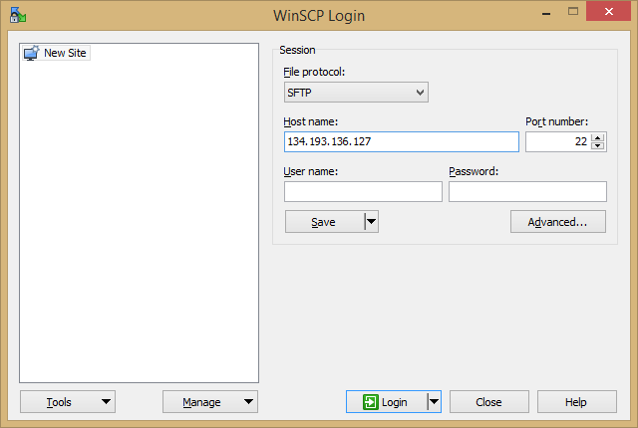

Enter hostname as 134.193.136.127 and Enter username and password as the group names.

Now WinSCP looks as follows:

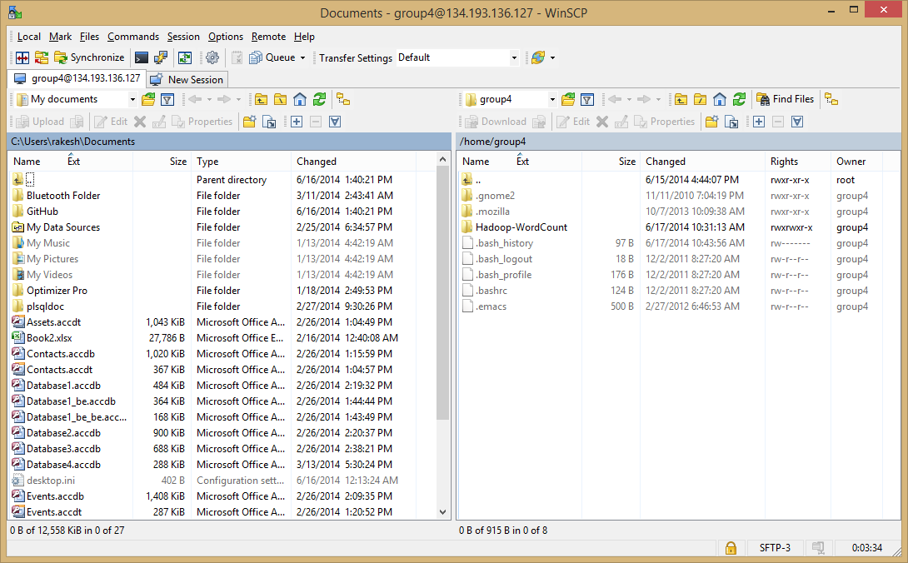

Left panel is windows and right panel is linux server. To Transfer files from windows to cloudera, we can drag the file from windows (left panel) and drop them in the linux server.

In the following screen we can notice file Database4.accdb is transferred from windows to linux

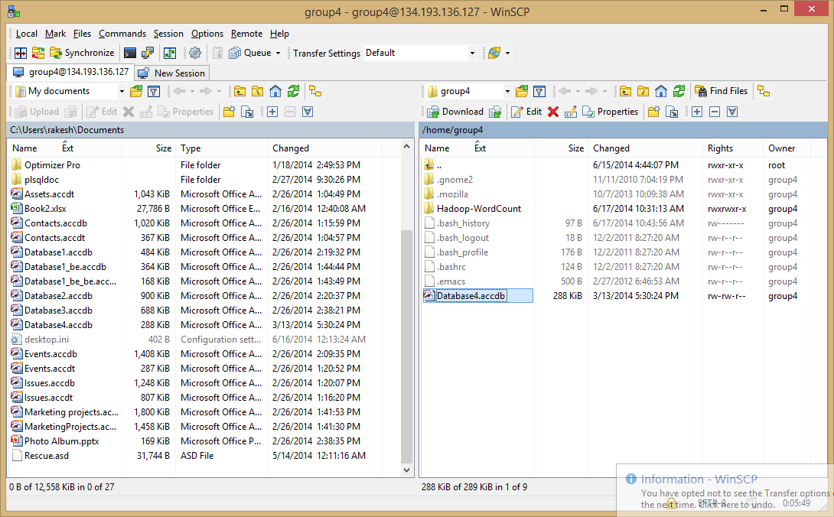

**SubTask4: How to run word count on Cloudera**

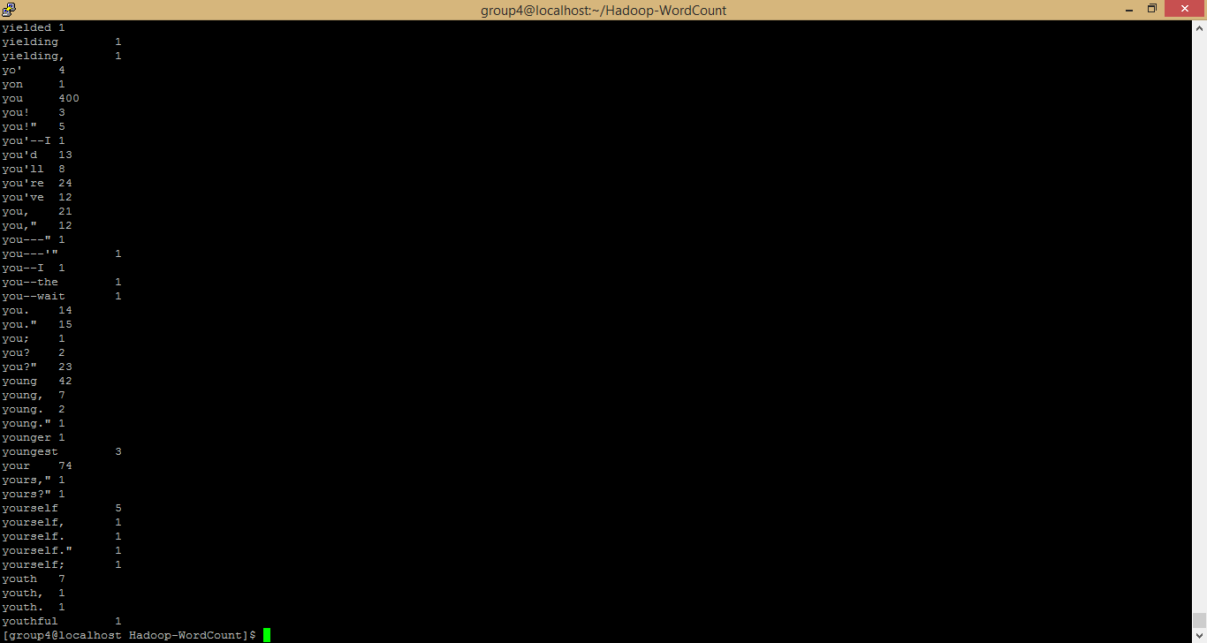

Put the wordcount.jar file in the cloudera and open the putty to run the wordcount jar file.

Use following commands to run the wordcount.jarfile

>>put local input file to the hadoop input directory:

* **hadoop fs –put input input**

>> Run Hadoop

* **hadoop jar wordcount.jar WordCount input output3**

>> View result from output3

* **hadoop fs -cat output3/\***

**SubTask5: How to make hadoop.jar and run it on Cloudera**

* Import the WordCountExercise project into the Eclipse in your Linux machine
* Export the project as jar file and run it using the steps mentioned in Subtask4

**SubTask6: How to build a java based restful service in cloudera**

* First Install OEPE Juno in the machine. This software could be downlaoded from the following location

<http://www.oracle.com/technetwork/developer-tools/eclipse/downloads/oepe-1211-1357594.html>

download and install it.

**Task3**

**Task1 - Login and create an account**

GitHub is a gui tool to maintain and manage the repository. It can be used for teamwork by working on a single file from remote locations.

>> First login to <http://www.github.com> which is as follows

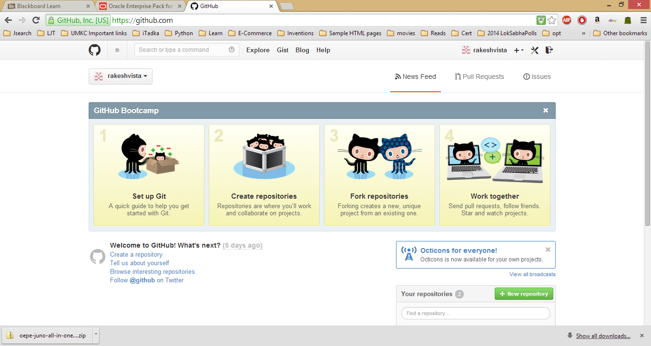

>> create a new repository

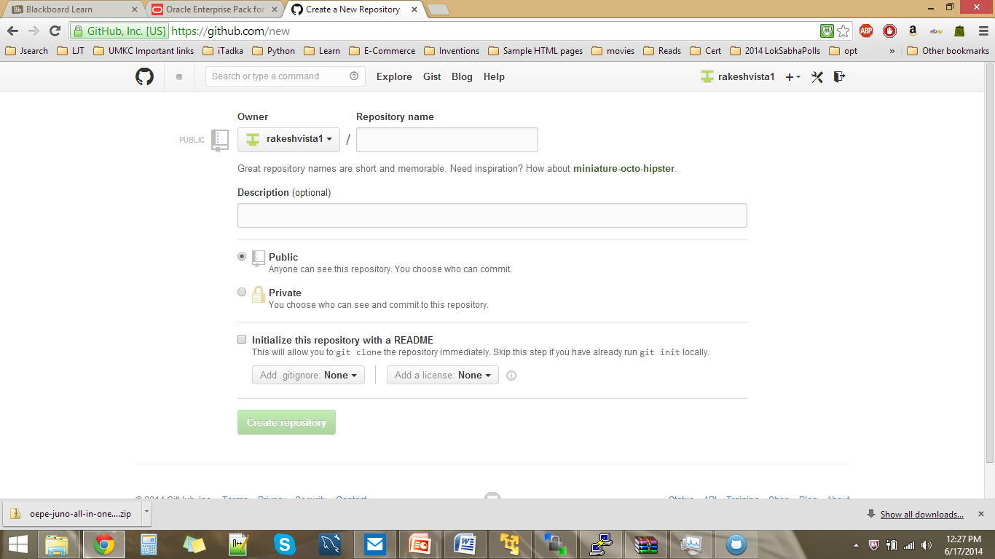

**Task2 - Login github for windows**



